Home page
Design reference | Original copy | Edited copy
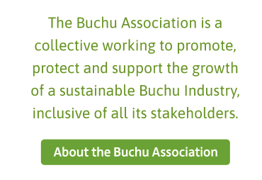 | No copy supplied | The Buchu Association is a collective working to promote, protect and support the growth of a sustainable buchu industry that is inclusive of all its stakeholders.
 | About the Buchu Association | About the Buchu Association
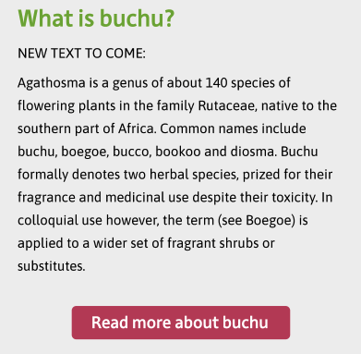 | What is Buchu?  Buchu, an indigenous plant endemic to the Western Cape well known for its unique and amazing fragrance and health benefits. The Buchu Industry is around 300 years old and mostly uses two species of the plant - Agathosma betulina and Agathosma crenulata – from predominantly cultivated sources. Buchu is primarily processed into an essential oil for use in the flavour and fragrance industry, but also into dried leaf for herbal infusions. Its medicinal qualities have led to recent increased popularity as an ingredient in the health & wellness, cosmetic and medicinal markets. | What is buchu?  Buchu is an indigenous plant endemic to the Western Cape. It is highly regarded for its unique fragrance and amazing health benefits.  Buchu has been commercially grown for almost 300 years. Farmers mainly use two species of the plant from predominantly cultivated sources: Agathosma betulina and Agathosma crenulata. Buchu essential oils are used in the flavour and fragrance industries, and dried buchu leaf is a popular addition to herbal infusions. Owing to its medicinal qualities, it has become increasingly popular as an ingredient in the health and wellness, cosmetic and medicinal markets.
 | Read more about buchu | Read more about buchu

About

Vision
Design reference | Original copy | Edited copy
 | The creation of a resilient and vibrant Buchu Industry able to take advantage of global market opportunities and create value for all involved. | The Buchu Association exists to create a resilient and vibrant buchu industry that is well positioned to take advantage of global market opportunities and create value for all involved.
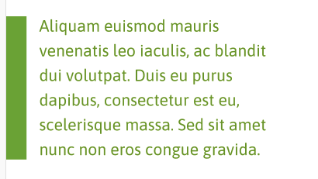 | No copy supplied

Strategic objectives

Design reference | Original copy | Edited copy
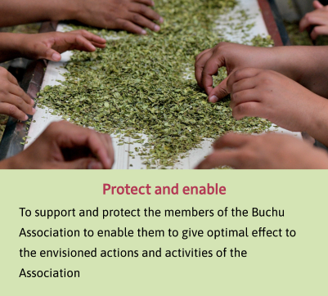 | Protect and enable: To support and protect the members of the Buchu Association to enable them to give optimal effect to the envisioned actions and activities of the Association | Protect and enable  Support and protect all Buchu Association members, empowering them to advance the goals and objectives of the Association and the buchu industry as a whole.
 | Represent and promote: To represent the Buchu Industry on regulatory level in a strategic manner and to engage proactively with relevant parties on national and international level to protect and promote the interest of the Industry | Represent and promote  Ensure the strategic interests of the buchu industry are represented on a regulatory level. Engage proactively with national and international stakeholders across the value chain to protect and promote the interests of Buchu Association members.
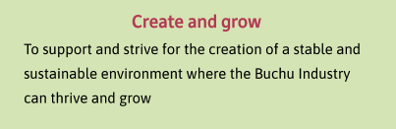 | Create and grow: To support and strive for the creation of a stable and sustainable environment where the Buchu Industry can thrive and grow | Create and grow  Create a vibrant and sustainable environment within which buchu producers and other stakeholders can flourish.
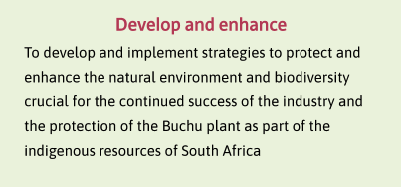 | Develop and enhance: To develop and implement strategies to protect and enhance the natural environment and biodiversity crucial for the continued success of the industry and the protection of the Buchu plant as part of the indigenous resources of South Africa | Develop and enhance  Protect and enhance the natural environment and biodiversity crucial for the continued success of the buchu industry. Act as custodians for buchu as an indigenous resource of South Africa, including commercially farmed buchu and subspecies or undiscovered species found in the wild.

Members

Design reference | Original copy | Edited copy
 | Meet the members | Meet the members

Board Members
Inactive on launch

Membership

Design reference | Original copy | Edited copy
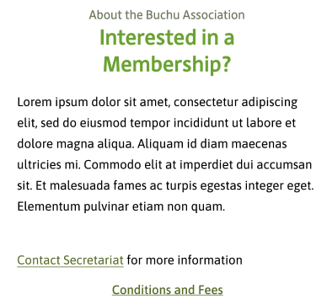 | The Buchu Association is a voluntary industry organisation working to promote, protect and support the growth of a sustainable Buchu Industry. The Association offers two types of membership:  - Full membership open to supply chain actors involved in the processing of Buchu. Membership benefits include:  - Exclusive access to Buchu industry data and order and promotional requests  - Support with biotrade and bioprospecting permits  - Access to development opportunities  - Direct support with trade challenges  - Promotion, marketing and visibility  - Business networking and influencing the strategic direction of the industry  - A common voice to government  - Associate membership open to supply chain actors involved in the processing of Buchu, Buchu brands and Research organizations. Membership benefits include:  - Promotion, marketing and visibility  - Exclusive access to information and order and promotional requests  - Business networking  - A common voice to government | Interested in a membership?  The Buchu Association is a voluntary industry organisation working to promote, protect and support the growth of a sustainable buchu industry. The Association offers two types of membership:  1. Full membership is open to supply chain actors involved in the processing of buchu. Membership benefits include:  - Exclusive access to buchu industry data and order and promotional requests  - Support with biotrade and bioprospecting permits  - Access to development opportunities  - Direct support with trade challenges  - Promotion, marketing and visibility  - Business networking and an opportunity to influence the strategic direction of the industry  - Industry advocacy to influence regulation and government decision-making  2. Associate membership is open to supply chain actors involved in the processing of buchu, as well as buchu brands and research organisations. Membership benefits include:  - Promotion, marketing and visibility  - Exclusive access to information and order and promotional requests  - Business networking  - Industry advocacy to influence regulation and government decision-making  Contact the secretariat for more information  Terms and conditions of membership and fees

Conditions of membership

Design reference | Original copy | Edited copy
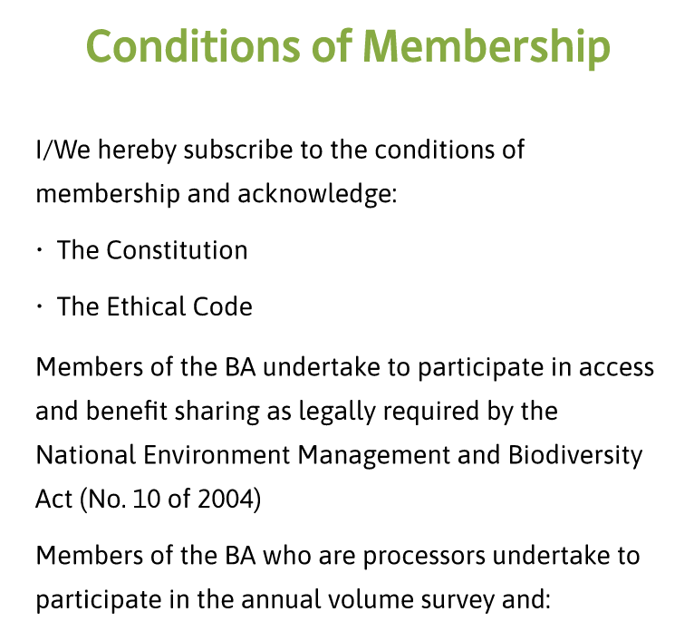 | From XD file | I/We hereby subscribe to the conditions of membership and acknowledge:  - The constitution  - The ethical code  Members of the Buchu Association undertake to participate in access and benefit sharing as legally required by the National Environment Management and Biodiversity Act (No. 10 of 2004).  Members who are processors undertake to participate in the annual volume survey and:  - Sign a non-disclosure agreement with PKF, the contracted accountants of the Buchu Association  - Submit audited volumes to PKF every year.  Fees  - Members are requested to pay a once-off joining fee of R10 000.  - The annual membership fee is R20 000.  - Membership is suspended if annual membership has not been paid by 31 July of each year.  - Interest is payable at the prime rate of interest as published by ABSA Group Limited on any overdue joining and membership fees.  Buchu Association | Registration number: 249-247 NPO

About buchu

Area overview

Design reference | Original copy | Edited copy
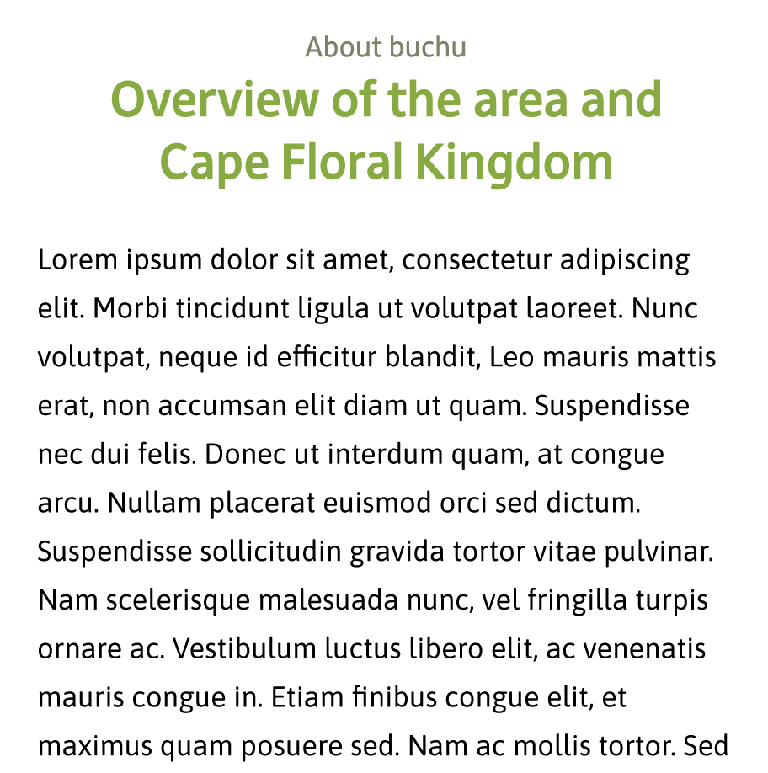 | Buchu is a Fynbos species endemic to the Cape Floral Kingdom in the Western Cape of South Africa. Buchu only grows in this area and nowhere else in the world and it comes as no surprise that the home of Buchu is as rare, beautiful and precious as the plant itself.  The Cape Floral Kingdom is the smallest of six Floral Kingdoms worldwide and the only one that is entirely within the borders of one country. Due to its extraordinary biodiversity – where more than 9600 species can be found within an area less than 90 000 km2 - it was added to the World Heritage Site list in 2004. It has also been identified as one of the world’s 35 biodiversity hotspots.  The Cape Floral Kingdom is one of the richest areas for plants when compared to any similar sized area in the world. It represents less than 0.5% of the area of Africa but is home to nearly 20% of the continent’s flora. The outstanding diversity, density and endemism of the flora are among the highest worldwide and is more botanically diverse than the Amazon rainforest.  What makes this level of biodiversity even more special is the high rate of endemism. A species of plant qualifies as endemic if it grows nowhere else in the world but one specific, geographic location. That’s the case with more or less 70% of the fynbos species. | Buchu is a fynbos species endemic to the Cape Floral Kingdom in the Western Cape of South Africa. As the plant only grows in this small geographic area and nowhere else in the world, it should come as no surprise that buchu is seen as an important cultural and natural asset.  The Cape Floral Kingdom is the smallest of six floral kingdoms worldwide and the only one that is entirely within the borders of one country. Owing to its extraordinary biodiversity – more than 9600 species can be found within an area of 90 000 km2 – it was added to the World Heritage list in 2004. It has also been identified as one of the world’s 35 biodiversity hotspots.  Compared to other, similarly sized ecological regions, the Cape Floral Kingdom is incredibly biodiverse. It represents less than 0.5% of the surface area of Africa, but is home to nearly 20% of the continent’s flora. The outstanding diversity and density of its flora are among the highest worldwide, and the region is more botanically diverse than the Amazon Rainforest.  What makes this level of biodiversity even more unique is the high rate of endemism. A plant species is endemic if it grows nowhere else in the world but one specific, geographic location. That is the case with about 70% of all fynbos species.
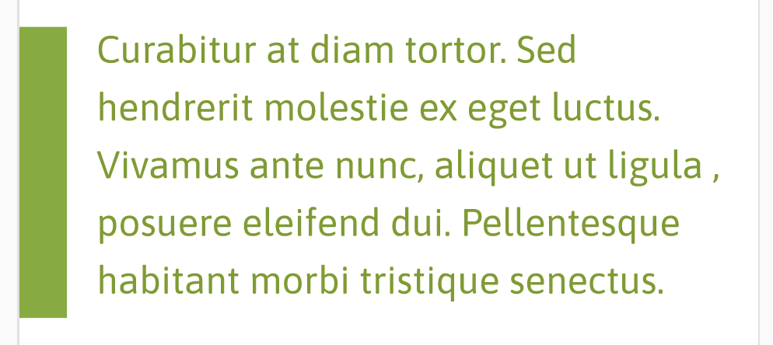 |  | Owing to its extraordinary biodiversity – more than 9600 species can be found within an area of 90 000 km2 – the Cape Floral Kingdom was added to the World Heritage list in 2004.

Plant description

Design reference | Original copy | Edited copy
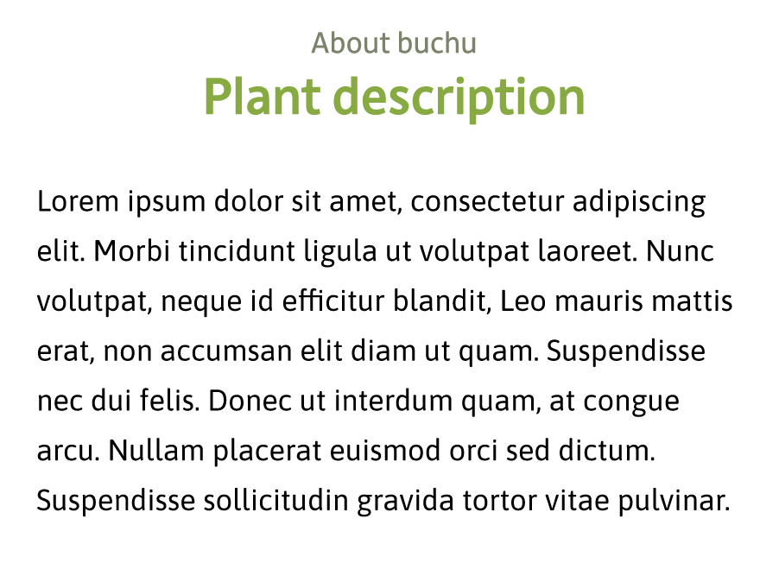 | Agathosma betulina is a resprouting, evergreen, broad-leaved, fragrant woody shrub that can grow to a height of up to 2 meters but is seldom more than 1m high. The plant stems are light green to dark red in colour, older stems have a grey/woody bark-like colour and appearance. The leaves are green in colour, about 20mm long and leathery and glossy and are situated on opposite sides of the stem. Round essential oil glands can clearly be seen on the leaf. The leaves have a finely serrated margin and distinctive "scratchy" feel to the hand. The flowers are large, star-shaped, five petalled, usually solitary and white to purplish pink in colour. Flowering usually occurs between June and November. Unripe seed pods are green and turn darker/brownish upon ripening when the pods split open to disperse the seeds.  Agathosma crenulata is an evergreen, fragrant woody shrub that grows to a height of up to 3 meters, and in extreme mature cases takes on the appearance of a young willow tree, with woody stems of up to 5cm in diameter. Younger plant stems are light green to dark red in colour, while older stems have a grey/woody bark-like colour. The leaves are more elongated than Agathosma betulina, (±30mm long, and generally larger, and green to dark green in colour. They are also leathery and glossy, and situated opposite on the stems. Although the leaves are also serrated, Agathosma crenulata leaves, have a softer and less curved appearance and a softer, leathery feel to the touch. Round essential oil glands are also visible on the leaves. The flowers are large, star-shaped, five petalled, usually solitary, and white to purplish pink in colour. Unripe seed pods are green and turn darker/brownish upon ripening when the pods split open to disperse the seeds. | Two species of buchu are commercially grown and cultivated, namely agothosma betulina and agothosma crenulata.  Agathosma betulina is a resprouting, evergreen, broad-leaved, fragrant woody shrub. It grows to a height of up to 2 metres but seldom stands more than 1 metre high. The plant stems are light green to dark red in colour; older stems have a grey and woody, bark-like appearance.  The leaves grow in pairs on opposite sides of the stem. They are green, about 20mm long and leathery and glossy. Round essential-oil glands can clearly be seen on the leaf. The leaves have a finely serrated margin and distinctive "scratchy" feel to the hand.  The large flowers have five petals arranged in a star shape. They are usually solitary and white to purplish pink in colour. Flowering occurs between June and November.  Unripe seed pods are green and turn darker and brownish upon ripening. Pods split open to disperse the seeds.  Agathosma crenulata is an evergreen, fragrant woody shrub. It grows to a height of up to 3 metres, and in extreme mature cases takes on the appearance of a young willow tree, with woody stems of up to 5 cm in diameter.  Younger plant stems are light green to dark red in colour, while older stems have a grey and woody, bark-like appearance.  At ±30mm, the leaves are more elongated than agathosma betulina and generally larger. They are green to dark green in colour. They are also leathery and glossy, and situated opposite each other on the stems. The leaves are also serrated, but agathosma crenulata leaves have a softer and less curved appearance and are softer and more leathery to the touch. Round essential-oil glands are visible on the leaves.  Flowers and seed pods are similar in appearance to agothosma betulina.
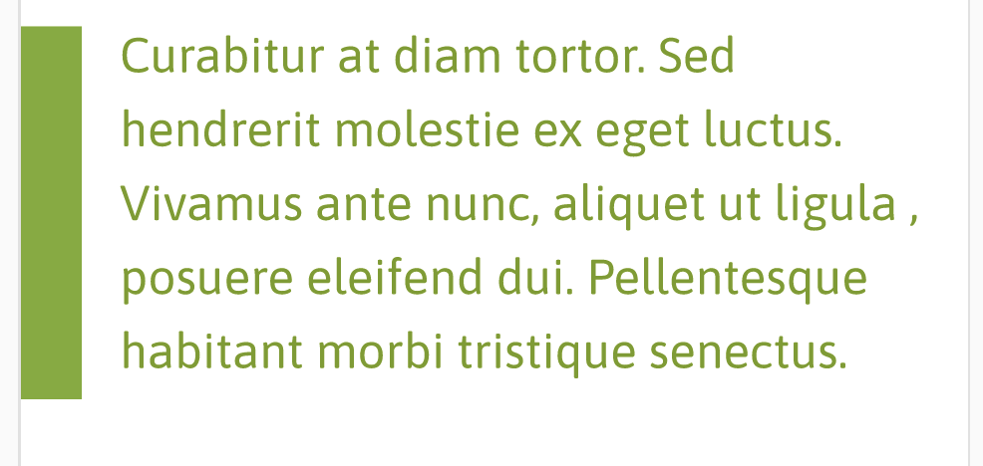 |  | In extreme mature cases agothosma crenulata takes on the appearance of a young willow tree, with woody stems of up to 5 cm in diameter.

History at a glance

Design reference | Original copy | Edited copy
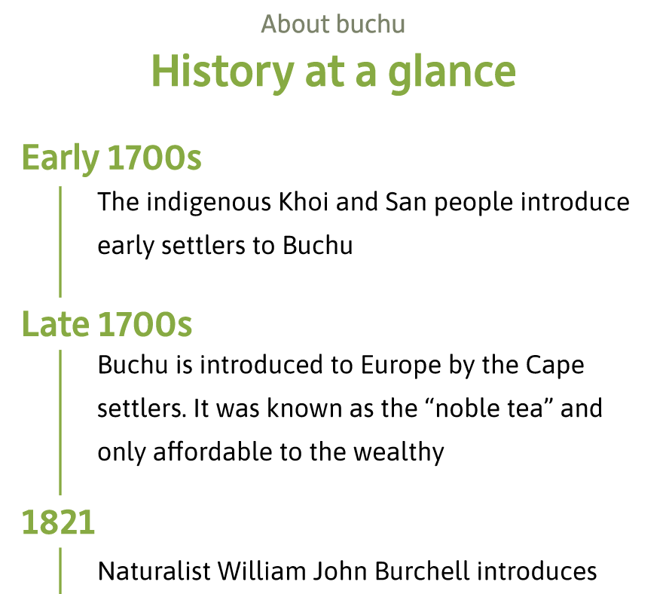 | - Early 1700s: The indigenous Khoikhoi and San people introduce early European settlers to Buchu  - Late 1700s: Buchu is introduced to Europe by the Cape settlers. It was known as the "noble tea" and only affordable to the wealthy  - 1821: Naturalist William John Burchell introduces Buchu to the medical profession. He created Buchu vinegar, which he used to heal skin wounds, and eventually Buchu brandy which he proclaimed "‘faster disappeared than could be accounted for by the wants of my patient”  - 1821: Buchu is officially registered in the British Pharmacopoeia as a diuretic  - 1860s: Buchu leaf imported into the United States as a panacea for a wide variety of ailments  - 10 April 1912: The Titanic sets sail from Southampton carrying eight bales of Buchu as noted in the cargo manifest  - 1920: The first commercial fields were planted on top of the Piketberg mountain by Frank Versveld  - 1970: Oil is extracted from the Buchu plant by means of steam distillation for the first time, making it possible to blend and produce pure Buchu oil  - 1977: Buchu is indexed in the American Merck Index, the British Martindale’s Edition and Scottish Medical Journal  - 15 January 2020: Mouton’s Valley, Puris Natural Aroma Chemicals, Skimmelberg Fynbos Oils and Waterfall Health farms establish the Buchu Association  - 9 March 2022: Parceval joins the Buchu Association  - 14 September 2023: The Buchu Association signs an industry wide benefit sharing agreement with the Khoikhoi and San peoples as the traditional knowledge holders on Buchu | Early 1700s  The indigenous Khoikhoi and San people introduce early European settlers to buchu.  Late 1700s  Cape settlers introduce buchu into Europe. It was known as the "noble tea" and only affordable to the wealthy.  1821  Naturalist William John Burchell introduces buchu to the medical profession. He created buchu vinegar, which he used to heal skin wounds, as well as Buchu brandy, which he proclaimed “faster disappeared than could be accounted for by the wants of my patient”.  1821  Buchu is officially registered in the British Pharmacopoeia as a diuretic.  1860s  Buchu leaf is imported into the United States as a panacea for a wide variety of ailments.  10 April 1912  The Titanic sets sail from Southampton carrying eight bales of buchu, as noted in the ill-fated ship’s cargo manifest.  1920  Frank Versfeld plants the first commercial buchu fields on top of Piketberg mountain.  1970  Oil is extracted from the Buchu plant by means of steam distillation for the first time, making it possible to blend and produce pure buchu oil.  1977  Buchu is indexed in the American Merck Index, the British Martindale’s Edition and Scottish Medical Journal.  15 January 2020  Mouton’s Valley, Puris Natural Aroma Chemicals, Skimmelberg Fynbos Oils and Waterfall Health farms establish the Buchu Association.  9 March 2022  Parceval joins the Buchu Association.  14 September 2023  The Buchu Association signs an industry-wide benefit-sharing agreement with the Khoikhoi and San peoples as the traditional knowledge holders on buchu.

The buchu industry

Industry overview

Design reference | Original copy | Edited copy
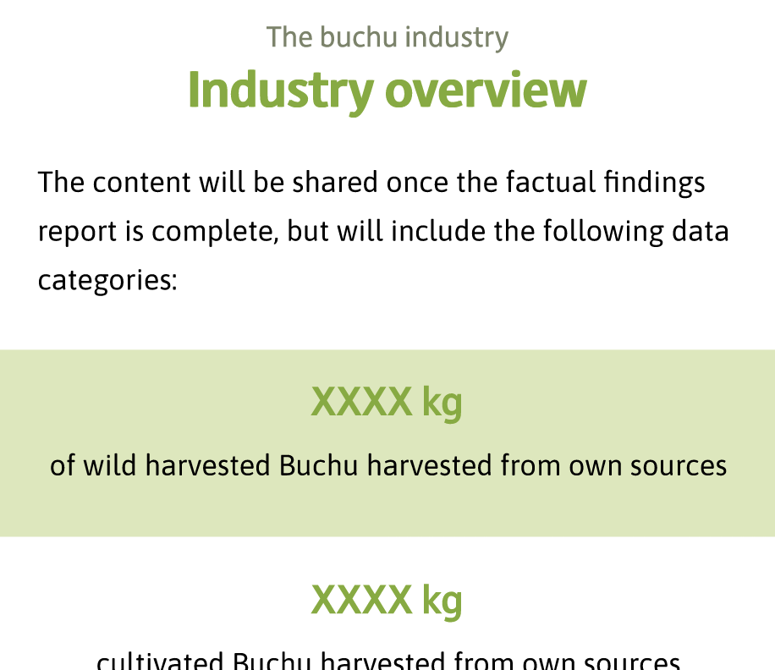 | - The members of the Buchu Association provide income and employment to at least 80 people  - It is estimated that about 1800 jobs are provided in the wider industry  - Currently there is 126 ha under Buchu cultivation  - On average approximately 750 tons of Buchu is harvested per year  - The majority of Buchu volumes is processed into essential oil  - Europe is the main destination for Buchu exports | 80 people  are gainfully employed and receive an income from members of the Buchu Association  1 800 jobs  created in the buchu value chain  126 ha  used for buchu cultivation  750 tons  of buchu is harvested per year  Essential oil  is the main end product for buchu production  Europe  is the main destination for buchu exports

Access and benefit sharing

Design reference | Original copy | Edited copy
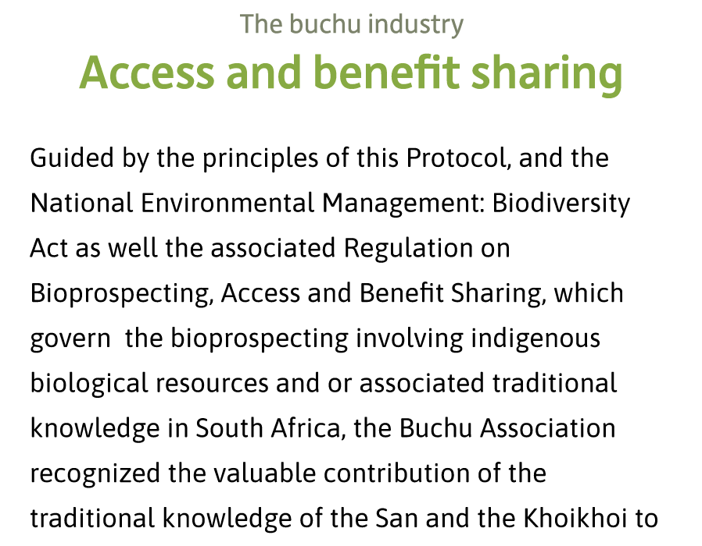 | Based on the principles of the Nagoya Protocol and the National Environmental Management: Biodiversity Act governing access and benefit sharing in the South African context, the Buchu Association recognized the valuable contribution of the traditional knowledge of the San and the Khoikhoi to the Buchu Industry. In 2020, the Association then proceeded to enter into industry wide benefit sharing negotiations with the National Khoi and San Council and the South African San Council as the representatives of the San and Khoikhoi peoples of South Africa.  The collaborative process initiated by the parties and supported and facilitated by the Department of Forestry, Fisheries and the Environment (DFFE) culminated in the signing of a pioneering industry wide benefit sharing agreement on 14 September 2023.  The agreement is the second of its kind in the world and speaks to the commitment of the parties to join hands and work in partnership for the benefit of all that holds knowledge on Buchu and all those that work with the indigenous resource in the industry. The model used in this agreement is unique in that it includes a combination of monetary benefits and non-monetary benefits.  The Buchu Association sees the industry wide benefit sharing agreement as the basis of and a first step in moving beyond recognition and towards building a partnership with traditional knowledge holders where all stakeholders make a specific and unique contribution to the promotion and the growth of the industry. | The Buchu Association recognises the value of the San and the Khoikhoi peoples’ traditional knowledge and its lasting impact on the buchu industry. We are guided by the principles of the Nagoya Protocol and the National Environmental Management: Biodiversity Act governing access and benefit sharing in the South African context.  In 2020, the Buchu Association entered into benefit-sharing negotiations with the National Khoi and San Council and the South African San Council, acting as representatives of the San and Khoikhoi peoples of South Africa. The collaborative process was supported and facilitated by the Department of Forestry, Fisheries and the Environment (DFFE), and culminated in the signing of a pioneering industrywide benefit-sharing agreement on 14 September 2023.  The agreement is the second of its kind in the world and speaks to the commitment of the parties to work in partnership for the benefit of all who hold knowledge on buchu and all those who work with the indigenous resource. The agreement is unique in that it includes a combination of monetary and non-monetary benefits.  The Buchu Association sees the agreement as the first step in building a partnership with traditional knowledge holders, where all stakeholders make a specific and unique contribution to the promotion and the growth of the industry.
 |  | The agreement is the second of its kind in the world and speaks to the commitment of the parties to work in partnership for the benefit of all who hold knowledge on buchu and all those who work with the indigenous resource.

Sustainability

Design reference | Original copy | Edited copy
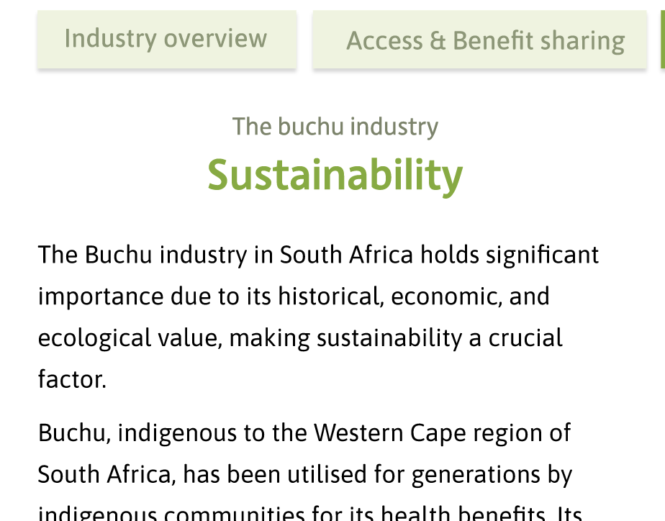 | The Buchu industry in South Africa holds significant importance due to its historical, economic, and ecological value, making sustainability a crucial factor.  Buchu, indigenous to the Western Cape region of South Africa, has been utilised for generations by indigenous communities for its health benefits. Its demand is steadily increasing globally due to its unique flavour and fragrance and its therapeutic properties in wellness products, leading to increased commercial cultivation.  A considered focus on sustainability is very important in preserving this resource. Overharvesting and habitat destruction pose threats to wild Buchu populations, emphasising the need for responsible cultivation practices. Sustainable farming techniques, including organic methods and biodiversity conservation, are imperative to maintain Buchu's natural habitat, ensuring its long-term viability.  Moreover, the Buchu industry significantly contributes to South Africa's economy, especially in rural areas. Sustainable practices not only protect the environment but also support livelihoods, providing income opportunities for local communities involved in cultivation, harvesting, and processing.  In essence, sustainability is the cornerstone of the Buchu industry's future. Balancing economic interests with environmental conservation is essential to safeguard this invaluable plant, ensuring its availability for generations to come while fostering socio-economic development in the region. | The buchu industry in South Africa holds significant importance due to its historical, economic and ecological value. Sustainability is a crucial factor in the management of this precious resource.  Buchu is endemic to the Western Cape region of South Africa. Indigenous communities have used it for generations for its health benefits. Its demand is steadily increasing globally due to its unique flavour and fragrance and its therapeutic properties. As a result, commercial cultivation is steadily increasing.  Overharvesting and habitat destruction pose threats to wild buchu populations, emphasising the need for responsible cultivation practices. Sustainable farming techniques, including organic methods and biodiversity conservation, are imperative to maintain buchu's natural habitat.  Moreover, the buchu industry significantly contributes to South Africa's economy, especially in rural areas. Sustainable practices not only protect the environment but also support livelihoods, providing income opportunities for local communities involved in cultivation, harvesting and processing.  In essence, sustainability is the cornerstone of the buchu industry's future. Balancing economic interests with environmental conservation is essential to safeguard this invaluable plant, ensuring its availability for generations to come while fostering socio-economic development in the region.
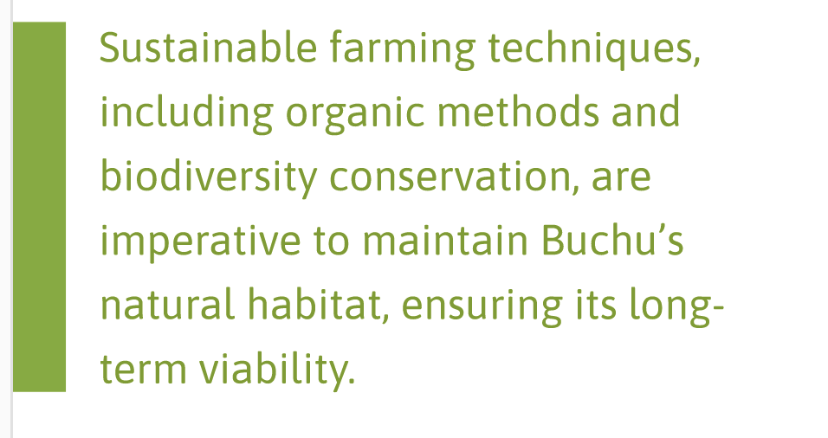
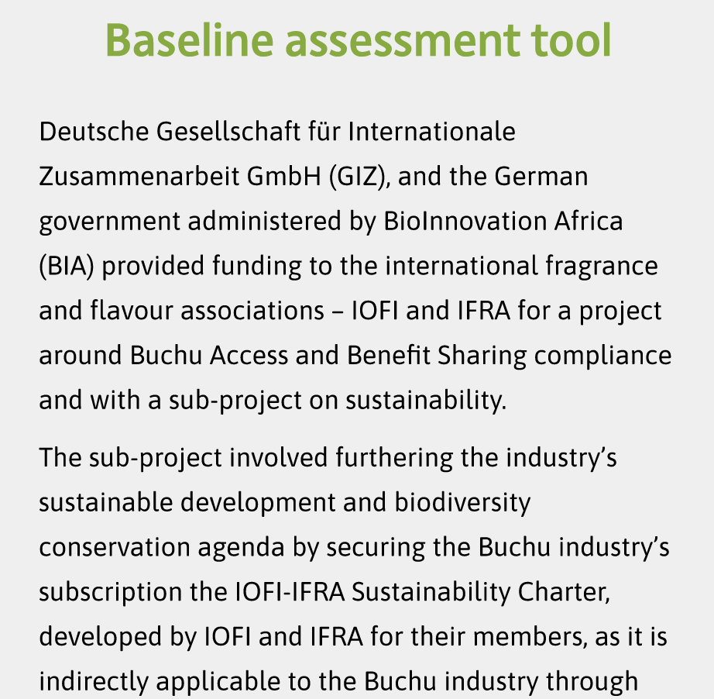 | Baseline assessment tool  Deutsche Gesellschaft für Internationale Zusammenarbeit GmbH (GIZ), and the German government administered by BioInnovation Africa (BIA) provided funding to the international fragrance and flavour associations – IOFI and IFRA for a project around Buchu Access and Benefit Sharing compliance and with a sub-project on sustainability.  The sub-project involved furthering the industry’s sustainable development and biodiversity conservation agenda by securing the Buchu industry’s subscription to the IOFI-IFRA Sustainability Charter, developed by IOFI and IFRA for their members, as it is indirectly applicable to the Buchu industry through Focus area 1 (raw material supplies). For this, a baseline assessment tool and local guidelines on sustainable Buchu cultivation and the conservation of surrounding biodiversity were needed to assist new producers joining the industry.  (link to Baseline Assessment Tool) | The Deutsche Gesellschaft für Internationale Zusammenarbeit GmbH and the German government provided funding for a project focused on buchu access and benefit-sharing compliance, with a sub-project on sustainability. The project was run by the International Organization of the Flavor Industry and the International Fragrance Association IFRA.  The sub-project involved furthering the industry’s sustainable development and biodiversity conservation agenda by securing the buchu industry’s subscription to the IOFI-IFRA Sustainability Charter. The charter is indirectly applicable to the buchu industry through Focus Area 1 of the charter (raw material supplies).  To assist new producers joining the industry, a baseline assessment tool and local guidelines on sustainable buchu cultivation and the conservation of surrounding biodiversity were developed.  Download self-assessment tool
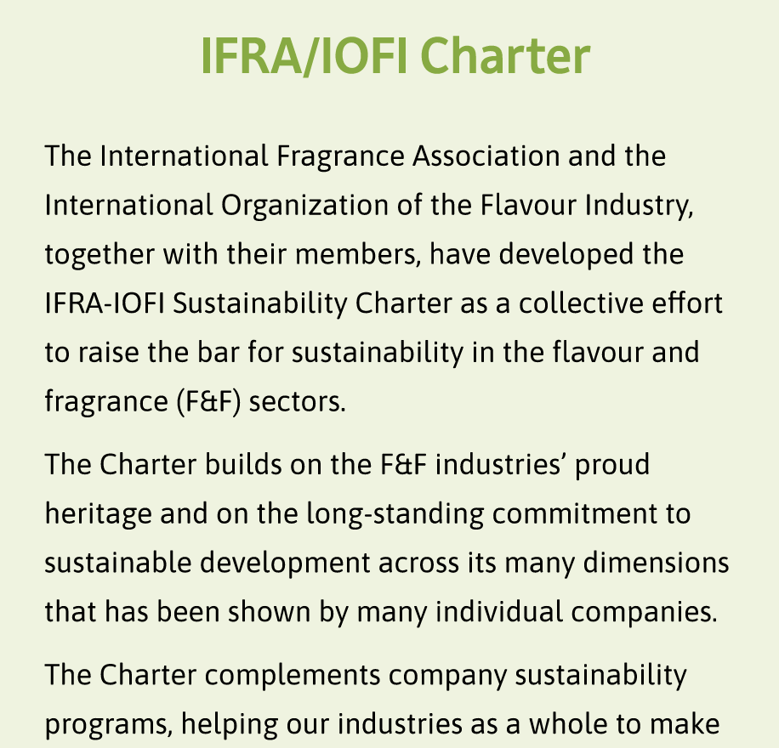 | IFRA/IOFI Charter  The International Fragrance Association and the International Organization of the Flavour Industry, together with their members, have developed the IFRA-IOFI Sustainability Charter as a collective effort to raise the bar for sustainability in the flavour and fragrance (F&F) sectors.  The Charter builds on the F&F industries’ proud heritage and on the long-standing commitment to sustainable development across its many dimensions that has been shown by many individual companies.  The Charter complements company sustainability programs, helping our industries as a whole to make advances on sustainability by sharing best practice and benchmarking progress.  (link to Charter: https://ifra-iofi.org/) | IFRA/IOFI Charter  The International Fragrance Association and the International Organization of the Flavor Industry, together with their members, have developed the IFRA-IOFI Sustainability Charter to raise the bar for sustainability in the flavour and fragrance sectors.  The charter builds on the flavour and fragrance industries’ proud heritage and on the long-standing commitment to sustainable development across its many dimensions, as demonstrated by many individual companies.  The charter is complementary to existing company sustainability programmes, helping our industries as a whole to make advances on sustainability by sharing best practices and benchmarking progress.  Visit the charter website

Geographical indication (save as draft)
Design reference | Original copy | Edited copy
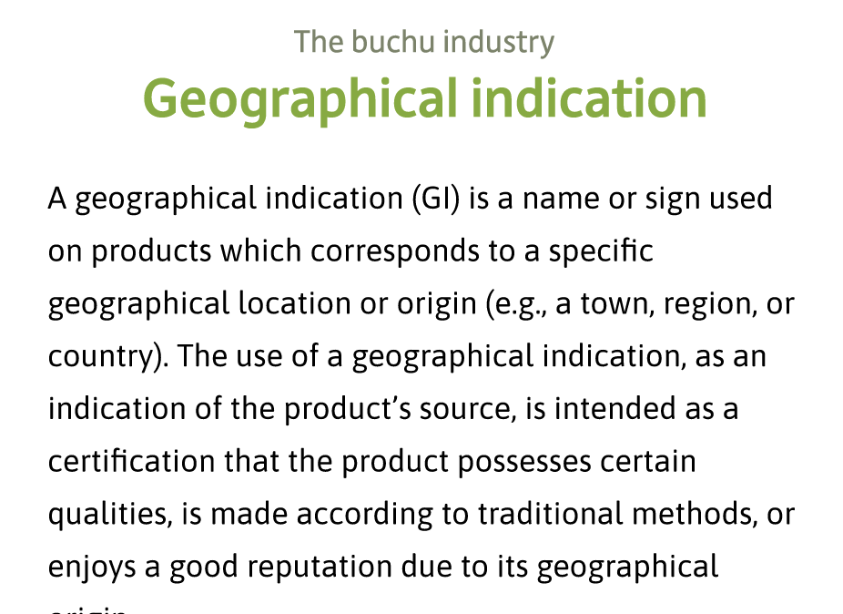 | A geographical indication (GI) is a name or sign used on products which corresponds to a specific geographical location or origin (e.g., a town, region, or country). The use of a geographical indication, as an indication of the product's source, is intended as a certification that the product possesses certain qualities, is made according to traditional methods, or enjoys a good reputation due to its geographical origin.  For GI’s there is a clear link between the product and its original place of production, and the Buchu Association decided to pursue a GI for Buchu as a proudly South African product only growing in the Cape Floral Kingdom of South Africa. The GI is currently under development and will help the industry to protect this valuable resource. | A geographical indication is a name or sign used on products to signify the product’s original, verified source within a specified region. The use of a geographical indication is intended as a certification that the product possesses certain qualities, is made according to traditional methods, or enjoys a good reputation due to its geographical origin.  Geographical indications make a clear link between the product and its original place of production, and the Buchu Association decided to pursue a geographical indication for buchu products. Buchu is a proudly South African product that only grows in the Cape Floral Kingdom of South Africa. The geographical indication is currently under development and will help the industry to protect this valuable resource.
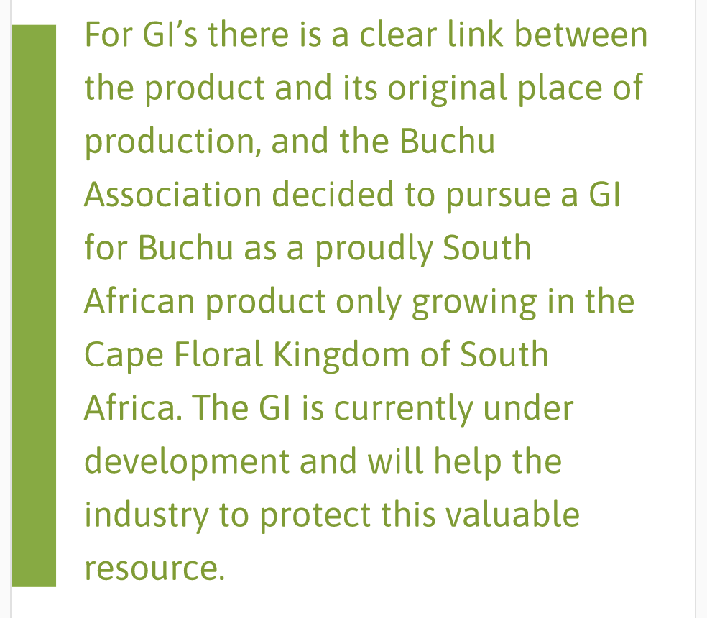 |  | The use of a geographical indication is intended as a certification that the product possesses certain qualities, is made according to traditional methods, or enjoys a good reputation due to its geographical origin.

Applicable regulation
Design reference | Original copy | Edited copy
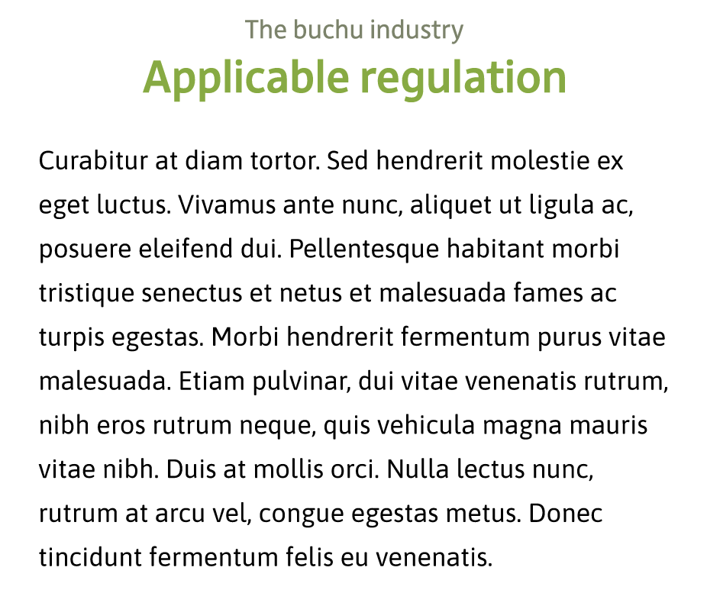 | The following Acts, regulations and Ordinances are applicable to members of the Buchu Industry:  - National Environmental Management Act 107 of 1998 National Environmental Management Act No. 107 of 1998 – Centre for Environmental Rights (cer.org.za)  - National Environmental Management: Biodiversity Act (Act no. 10 of 2004) – National Environmental Management: Biodiversity Act, 2004 – Centre for Environmental Rights (cer.org.za)  - Bioprospecting, Access and Benefit Sharing (BABS) Regulations, 2008 and Amendment Regulations, 2015 - 37331gen73.pdf (www.gov.za)  - Environmental Impact Assessment Regulations 2014 - EIA-Regulations-2014.pdf (cer.org.za)  - Western Cape Biodiversity Act No 6 of 2021 - Western-Cape-Biodiversity-Act-No.-6-of-2021-14-December-2021-effective-sections-1-August-2022-ENGLISH-ONLY_2023-08-22-203132_cjej.pdf (capenature.co.za)  - Cape Nature Conservation Ordinance 19 of 1974 - Nature-Conservation-Ordinance-19-of-1974_2021-05-31-075828_whkc.pdf (capenature.co.za) | The following acts, regulations and ordinances are applicable to members of the Buchu Industry:  - National Environmental Management Act No. 107 of 1998  - National Environmental Management: Biodiversity Act, 2004 – Centre for Environmental Rights  - Bioprospecting, Access and Benefit Sharing (BABS) Regulations, 2008 and Amendment Regulations, 2015  - Environmental Impact Assessment Regulations 2014  - Western Cape Biodiversity Act No 6 of 2021  - Cape Nature Conservation Ordinance 19 of 1974
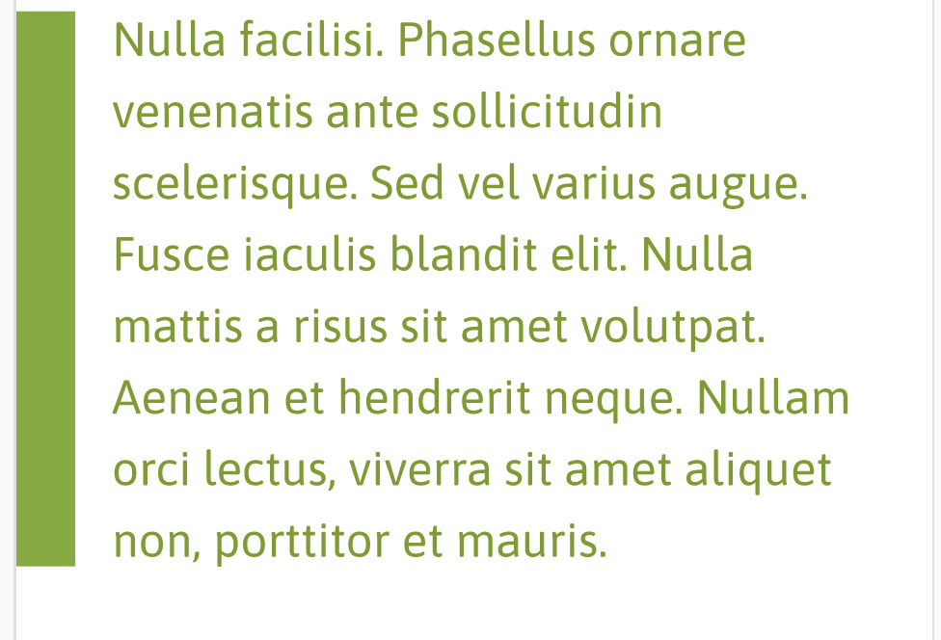 |  | Delete

Products and application

Buchu oil

Design reference | Original copy | Edited copy
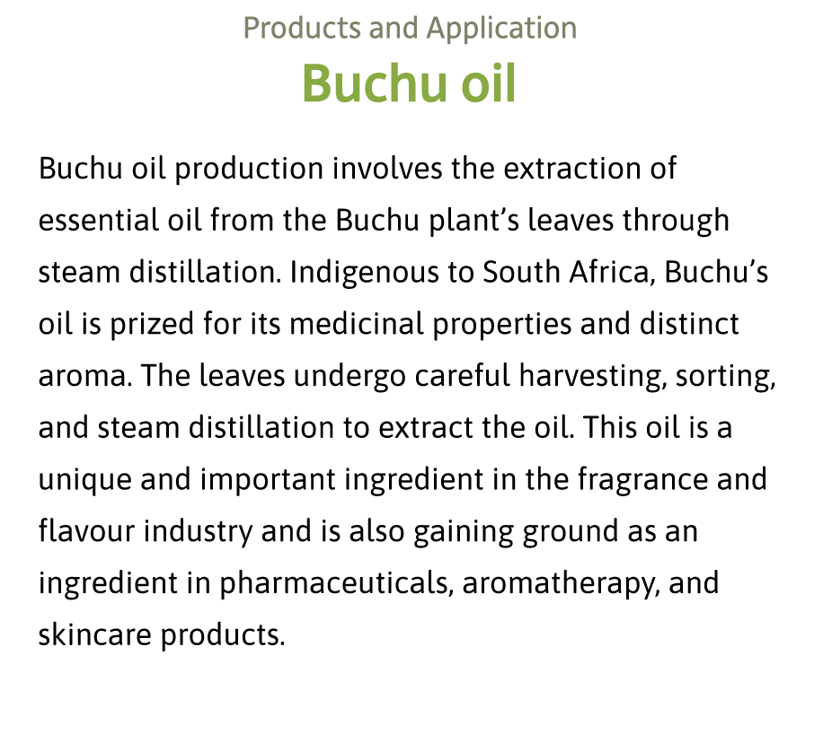 | Buchu oil: Buchu oil production involves the extraction of essential oil from the Buchu plant's leaves through steam distillation. Indigenous to South Africa, Buchu's oil is prized for its medicinal properties and distinct aroma. The leaves undergo careful harvesting, sorting, and steam distillation to extract the oil. This oil is an unique and important ingredient in the fragrance and flavour industry and is also gaining ground as an ingredient in pharmaceuticals, aromatherapy, and skincare products. | Buchu essential oil, derived from the leaves of the buchu plant, is produced through steam distillation. The oil is valued for its medicinal benefits and distinctive scent. Leaves are selectively harvested and sorted to ensure the highest quality.  Buchu oil serves as a key component in the fragrance and flavour industry, and its popularity is on the rise within the pharmaceutical, aromatherapy and skincare sectors, thanks to its unique properties and versatility.

Dried leaf

Design reference | Original copy | Edited copy
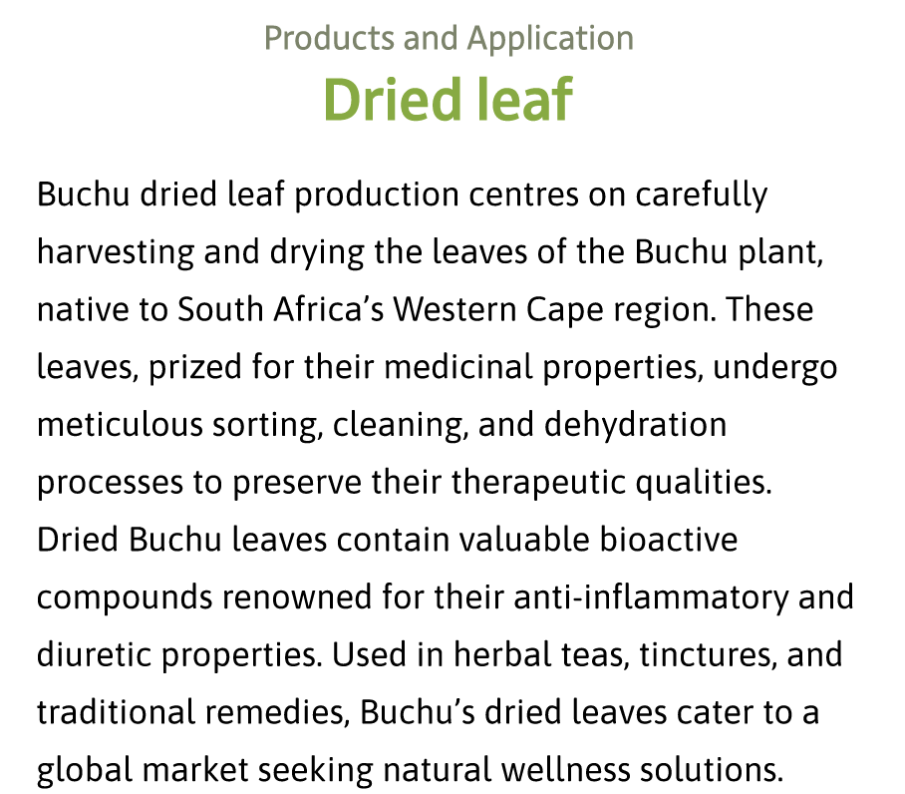 | Dried leaf: Buchu dried leaf production centres on carefully harvesting and drying the leaves of the Buchu plant, native to South Africa's Western Cape region. These leaves, prized for their medicinal properties, undergo meticulous sorting, cleaning, and dehydration processes to preserve their therapeutic qualities. Dried Buchu leaves contain valuable bioactive compounds renowned for their anti-inflammatory and diuretic properties. Used in herbal teas, tinctures, and traditional remedies, Buchu's dried leaves cater to a global market seeking natural wellness solutions. | Prized for their medicinal properties, buchu leaves undergo meticulous sorting, cleaning, and dehydration processes to preserve their therapeutic qualities.  Dried buchu leaves contain valuable bioactive compounds renowned for their anti-inflammatory and diuretic properties. They are utilised in herbal teas, tinctures, and traditional remedies, meeting the demands of a global market in search of natural health and wellness solutions.

Hydrosol
Design reference | Original copy | Edited copy
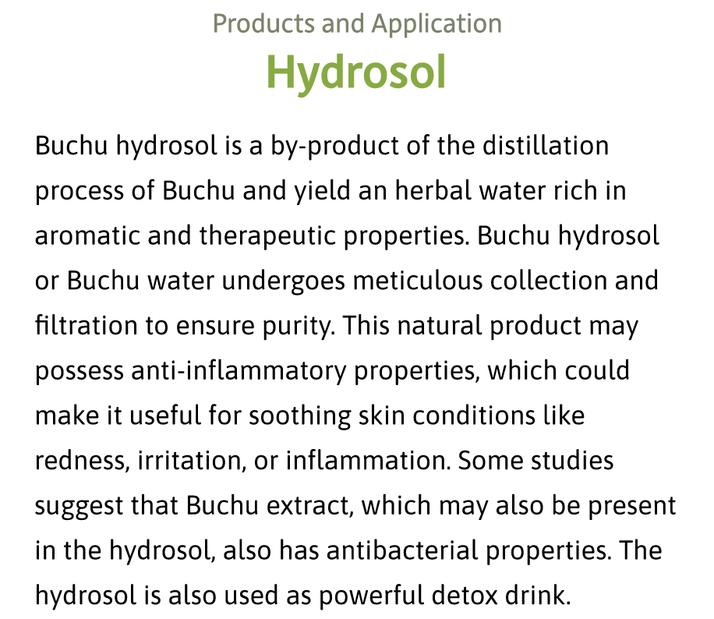 | Hydrosol: Buchu hydrosol is a by-product of the distillation process of Buchu that yields a herbal water rich in aromatic and therapeutic properties. Buchu hydrosol or Buchu water undergoes meticulous collection and filtration to ensure purity. This natural product may possess anti-inflammatory properties, which could make it useful for soothing skin conditions like redness, irritation, or inflammation. Some studies suggest that Buchu extract, which may also be present in the hydrosol, also has antibacterial properties. The hydrosol is also used as powerful detox drink. | Buchu hydrosol, also known as buchu water, is a fragrant herbal water enriched with therapeutic properties. It is created as a by-product during the buchu distillation process. The hydrosol is carefully collected and filtered to maintain its purity and effectiveness.  It is believed to possess anti-inflammatory qualities that may help soothe skin conditions such as redness, irritation and inflammation. Buchu extract present in the hydrosol may have antibacterial properties, enhancing its healing potential. Buchu hydrosol is also celebrated as a potent detoxifying beverage.

De-oiled leaf
Design reference | Original copy | Edited copy
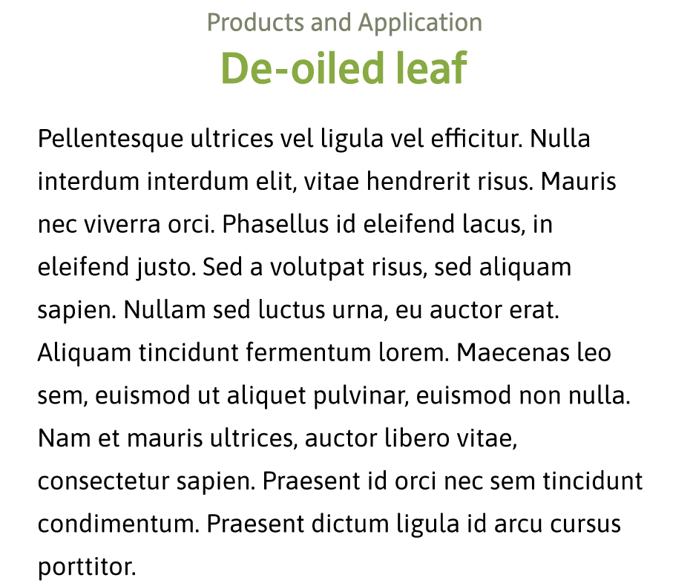 | De-oiled leaf: Many botanical products are known to contain natural antioxidants and bioflavonoids, usually in the form of non-volatile polyphenolic phytochemical constituents. In this regard Buchu is no exception. It contains generous amounts of the natural compounds called Quercetin, Rutin, Hesperidin and Diosmin, all of which have potent antioxidant and/or bioflavonoid properties. These non-volatile compounds are usually extracted as an additional byproduct from the de-oiled leaf after steam distillation and find application in the nutraceutical and antioxidant markets. | Many botanical products, including buchu, contain natural antioxidants and bioflavonoids, usually in the form of non-volatile polyphenolic phytochemical constituents. Buchu contains the natural compounds quercetin, rutin, hesperidin and diosmin, all of which have potent antioxidant and/or bioflavonoid properties. These non-volatile compounds are usually extracted as an additional by-product from the de-oiled leaf after steam distillation and find application in the nutraceutical and antioxidant markets.

Application
Design reference | Original copy | Edited copy
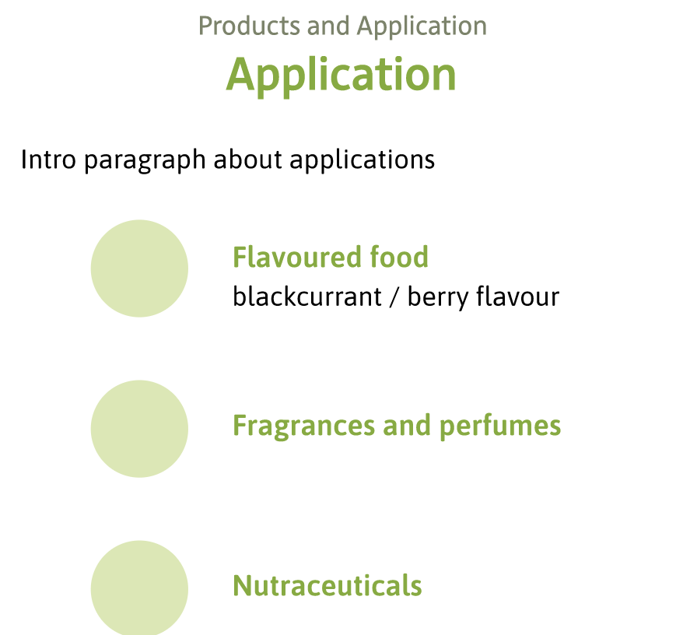 | - Flavoured food (blackcurrant / berry flavour)  - Fragrances and perfumes  - Nutraceuticals  - Cosmetics  - Health and Wellness  - Aromatherapy  - Herbal infusion (dried or ready-to-drink)  - Buchu water  - Functional foods and feeds  - Chocolate  - Craft alcohol products (brandy, gin and beer) | - Flavoured food  - Blackcurrant and berry flavours  - Fragrances and perfumes  - Nutraceuticals  - Cosmetics  - Health and wellness  - Aromatherapy  - Herbal infusion  - Dried or ready-to-drink  - Buchu water  - Functional foods and feeds  - Chocolate  - Craft alcohol  - Brandy, gin and beer

Gallery
Design reference | Original copy | Edited copy
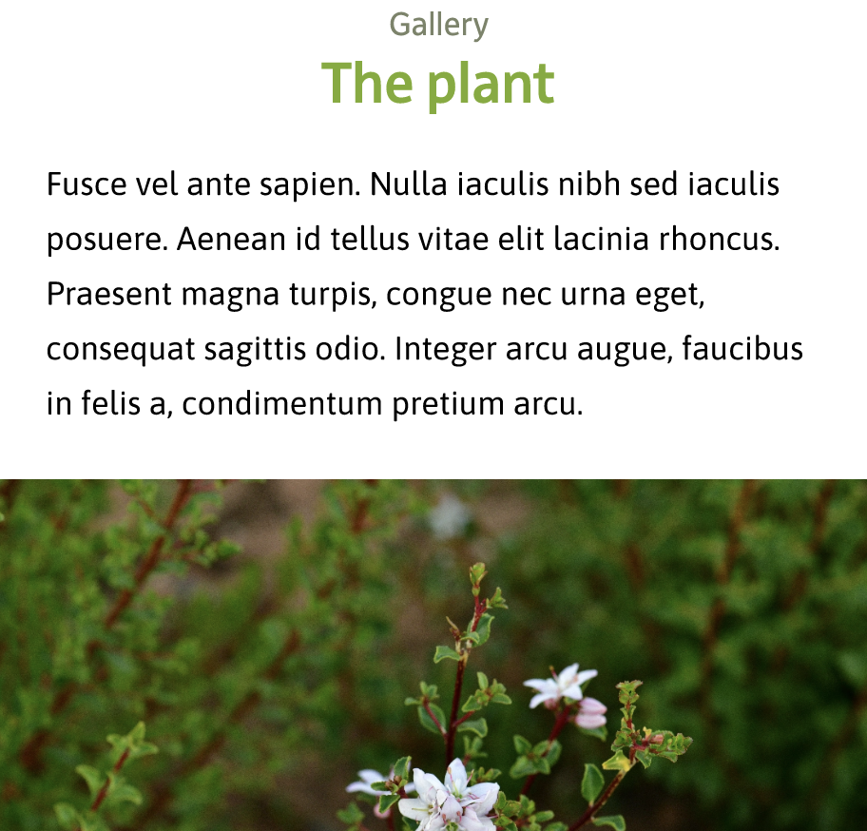 | Remove text and only keep the following headings with the photos:  - The plant  - Buchu cultivation  - Buchu harvesting  - Buchu processing | Headings  - The buchu plant  - Buchu cultivation  - Buchu harvesting  - Buchu processing

Contact
Design reference | Original copy | Edited copy
 | Buchu Secretariat  Marthane Swart  marthane@skaa.co.za | Buchu secretariat  Marthane Swart  marthane@skaa.co.za

